1. **Project goal:**

The primary and most important goal of the project is:

***“To design a remote controlled car and develop it’s control system”.***

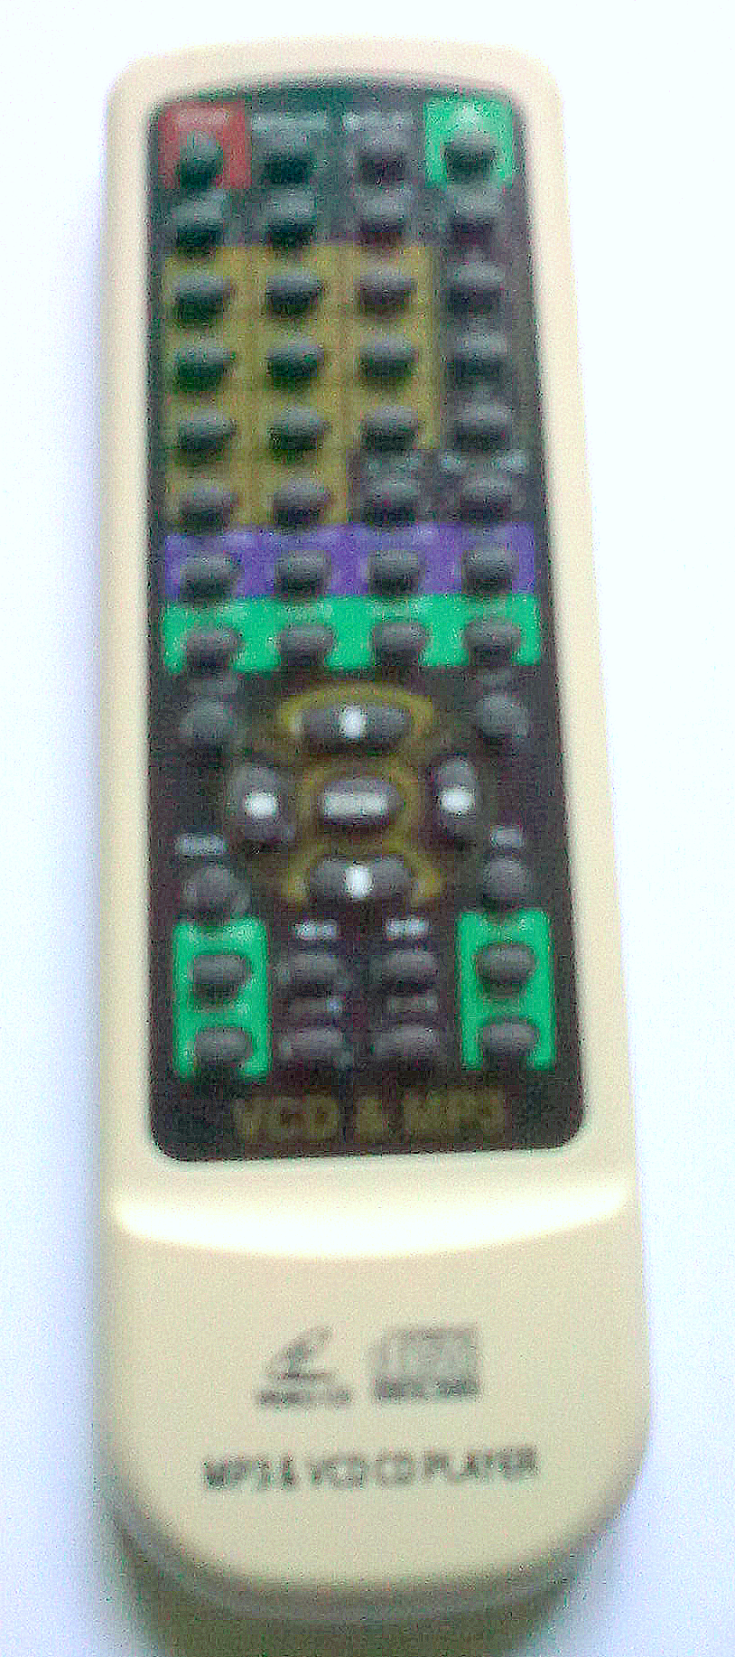

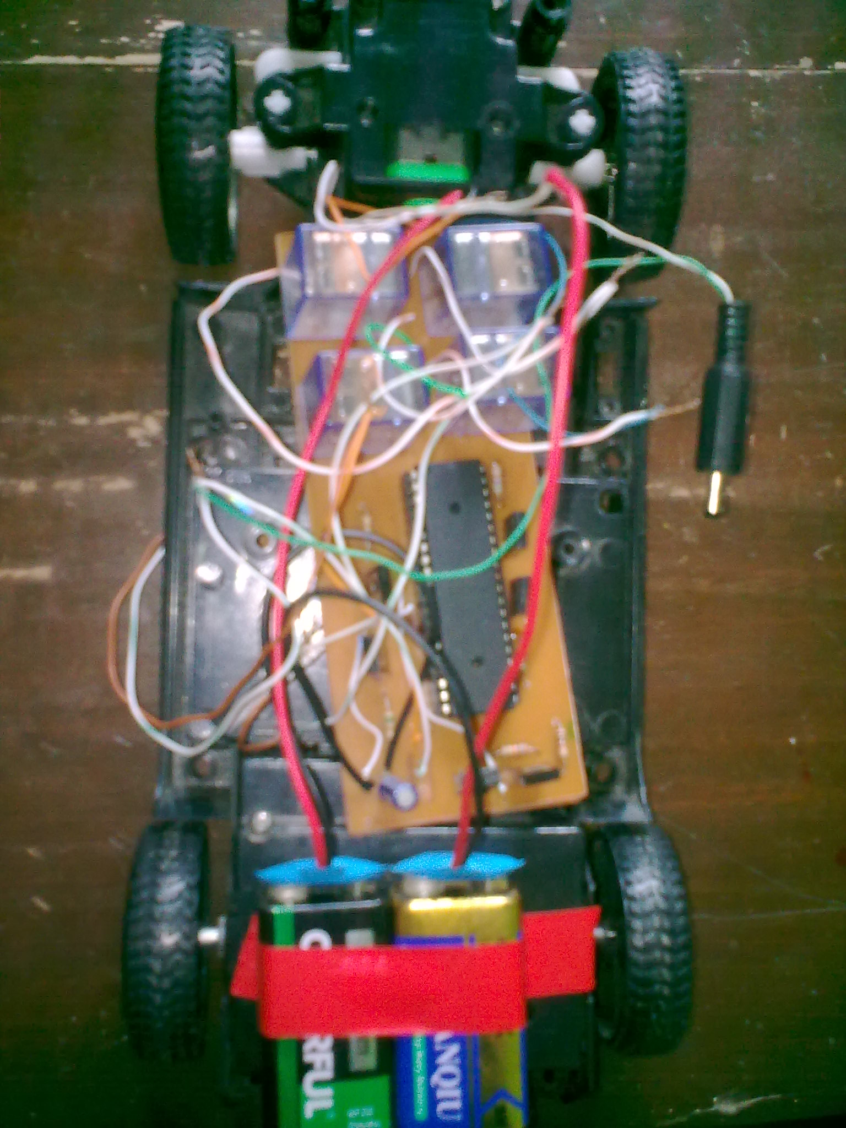

1. **Main parts**:

The main parts that are used in remote controlled car are listed below.

|  |  |  |  |  |
| --- | --- | --- | --- | --- |
| components | - | Specification | - | Quantity |
| 1. Microcontroller | - | ATmega32L | - | 1pcs |
| 2. Relay | - | 6V |  | 4pcs |
| 3. Transistor | - | BD135 | - | 5pcs |
| 4. Resistor | - | 560Ω,1kΩ,10kΩ | - | 4pcs,1pcs,1pcs |
| 5. Capacitor | - | 0.1µF | - | 2pcs |
| 6. Voltage regulator | - | 7805 | - | 1pcs |
| 7. Infrared sensor | - | - | - | 1pcs |
| 8. Infrared remote switch | - | VCD 3.0 | - | 1pcs |
| 9. Toy car | - | - | - | 1pcs |
| 10. Motor | - | 6V, 3V |  | 2pcs |
| 11. 40 pin base | - | - | - | 1pcs |
| 12. Battery | - | 9V | - | 2pcs |

1. **Description of main parts:**
2. **Construction of toy car:**

**Forward & Backward Motion System**

**Steering System**

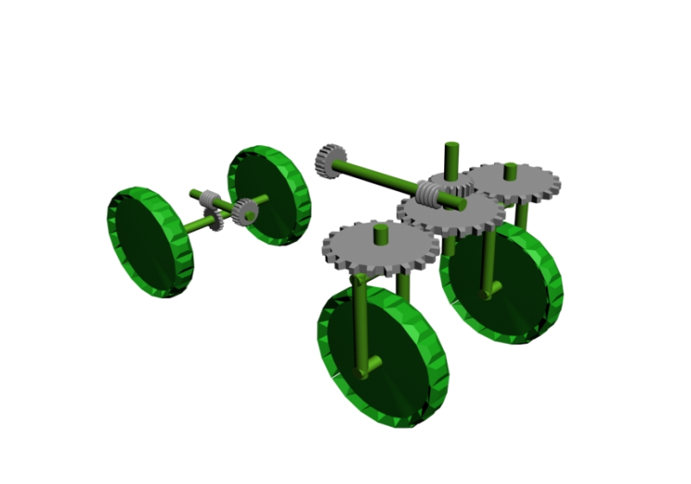

Fig.1: construction of a toy car.

1. **Electric motor:**

An electric motor converts electrical energy into mechanical energy. The reverse process of converting mechanical energy into electrical energy is accomplished by a generator or dynamo. Electric motors are found in household appliances such as fans, refrigerators, washing machines, pool pumps, floor vacuums, and fan-forced ovens.

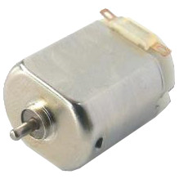

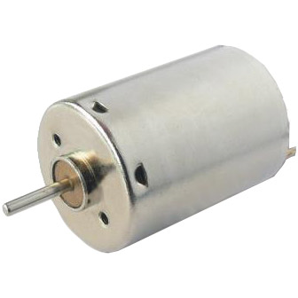

Fig.2: Different types of DC motor.

Most electric motors work by electromagnetism. The fundamental principle upon which electromagnetic motors are based is that there is a mechanical force on any current-carrying wire contained within a magnetic field. The force is described by the Lorentz force law and is perpendicular to both the wire and the magnetic field. In a rotary motor, the rotating part (usually on the inside) is called the rotor, and the stationary part is called the stator. The rotor rotates because the wires and magnetic field are arranged so that a torque is developed about the rotor's axis. The motor contains electromagnets that are wound on a frame. This frame is often called the armature. Correctly, the armature is that part of the motor across which the input voltage is supplied. Depending upon the design of the machine, either the rotor or the stator can serve as the armature.

1. **Input power source:**

In our remote controlled car we have used two DC motor. These DC motors get the power from two “9 volts DC BATTARY”.

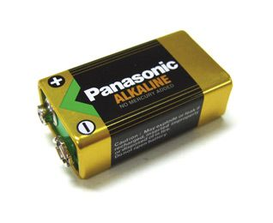

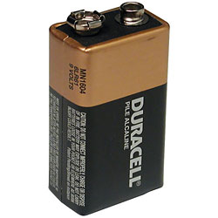

Fig.3: Different types of 9V battery (non rechargeable)

An electrical battery is a combination of one or more electrochemical cells, used to convert stored chemical energy into electrical energy. Since the invention of the first Voltaic pile in 1800 by Alessandro Volta, the battery has become a common power source for many household and industrial applications.

Batteries may be used once and discarded, or recharged for years as in standby power applications. Miniature cells are used to power devices such as hearing aids and wristwatches; larger batteries provide standby power for telephone exchanges or computer data centers.

1. **MICROCONTROLLER:**

A microcontroller is a small computer on a single integrated circuit containing a processor core, memory, and programmable input/output peripherals. Program memory in the form of NOR flash or OTP ROM is also often included on chip, as well as a typically small amount of RAM. Microcontrollers are designed for embedded applications, in contrast to the microprocessors used in personal computers or other general purpose applications.

Microcontrollers are used in automatically controlled products and devices, such as automobile engine control systems, implantable medical devices, remote controls, office machines, appliances, power tools, and toys. By reducing the size and cost compared to a design that uses a separate microprocessor, memory, and input/output devices, microcontrollers make it economical to digitally control even more devices and processes. Mixed signal microcontrollers are common, integrating analog components needed to control non-digital electronic systems.

1. **ATmega32L:**

The ATmega32L is a low-power CMOS 8-bit microcontroller based on the AVR enhanced RISC architecture. By executing powerful instructions in a single clock cycle, the ATmega32 achieves throughputs approaching 1 MIPS per MHz allowing the system designer to optimize power consumption versus processing speed.

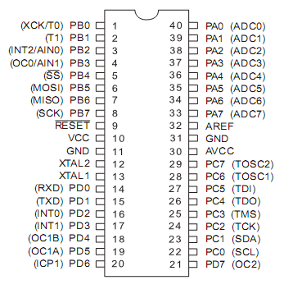

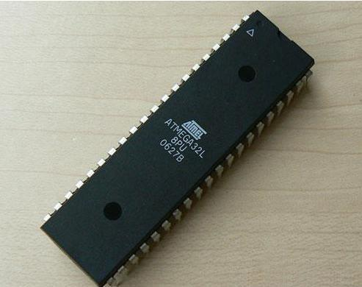

Fig.4: Physical view & pin diagram of ATmega32L

1. **Features:**
2. High-performance, Low-power AVR® 8-bit Microcontroller
3. Advanced RISC Architecture
   1. 131 Powerful Instructions – Most Single-clock Cycle Execution
   2. 32 x 8 General Purpose Working Registers
   3. Fully Static Operation
   4. Up to 16 MIPS Throughput at 16 MHz
4. High Endurance Non-volatile Memory segments
   1. 32K Bytes of In-System Self-programmable Flash program memory
   2. 1024 Bytes EEPROM
   3. 2K Byte Internal SRAM
   4. Write/Erase Cycles: 10,000 Flash/100,000 EEPROM
   5. Data retention: 20 years at 85°C/100 years at 25°C
   6. In-System Programming by On-chip Boot Program
   7. True Read-While-Write Operation
   8. Programming Lock for Software Security
5. Peripheral Features
   1. Two 8-bit Timer/Counters with Separate Prescalers and Compare Modes
   2. One 16-bit Timer/Counter with Separate Prescaler, Compare Mode, and Capture Mode
   3. Real Time Counter with Separate Oscillator
   4. Four PWM Channels
   5. 8-channel, 10-bit ADC
   6. Byte-oriented Two-wire Serial Interface
   7. Programmable Serial USART
   8. Master/Slave SPI Serial Interface
   9. Programmable Watchdog Timer with Separate On-chip Oscillator
   10. On-chip Analog Comparator
6. I/O and Packages
   1. 32 Programmable I/O Lines
   2. 40-pin PDIP
7. Operating Voltages
   1. 2.7 - 5.5V for ATmega32L
8. Speed Grades
   1. 0 - 8 MHz for ATmega32L
9. Power Consumption at 1 MHz, 3V, 25°C for ATmega32L
   1. Active: 1.1 mA
   2. Idle Mode: 0.35 mA
   3. Power-down Mode: < 1 μA
10. **RELAY:**

A relay is an electrically operated switch. Many relays use an electromagnet to operate a switching mechanism, but other operating principles are also used. Relays find applications where it is necessary to control a circuit by a low-power signal, or where several circuits must be controlled by one signal.

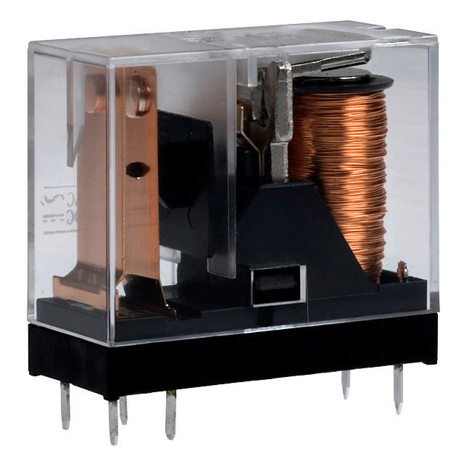

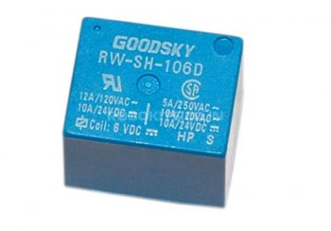

Fig.5: Different types of relays

The first relays were used in long distance telegraph circuits, repeating the signal coming in from one circuit and re-transmitting it to another. Relays found extensive use in telephone exchanges and early computers to perform logical operations. A type of relay that can handle the high power required to directly drive an electric motor is called a contactor. Solid-state relays control power circuits with no moving parts, instead using a semiconductor device to perform switching. Relays with calibrated operating characteristics and sometimes multiple operating coils are used to protect electrical circuits from overload or faults; in modern electric power systems these functions are performed by digital instruments still called "protection relays".

1. **Transistor:**

A transistor is a semiconductor device used to amplify and switch electronic signals. It is made of a solid piece of semiconductor material, with at least three terminals for connection to an external circuit. A voltage or current applied to one pair of the transistor's terminals changes the current flowing through another pair of terminals. Because the controlled power can be much more than the controlling power, the transistor provides amplification of a signal. Some transistors are packaged individually but many more are found embedded in integrated circuits.

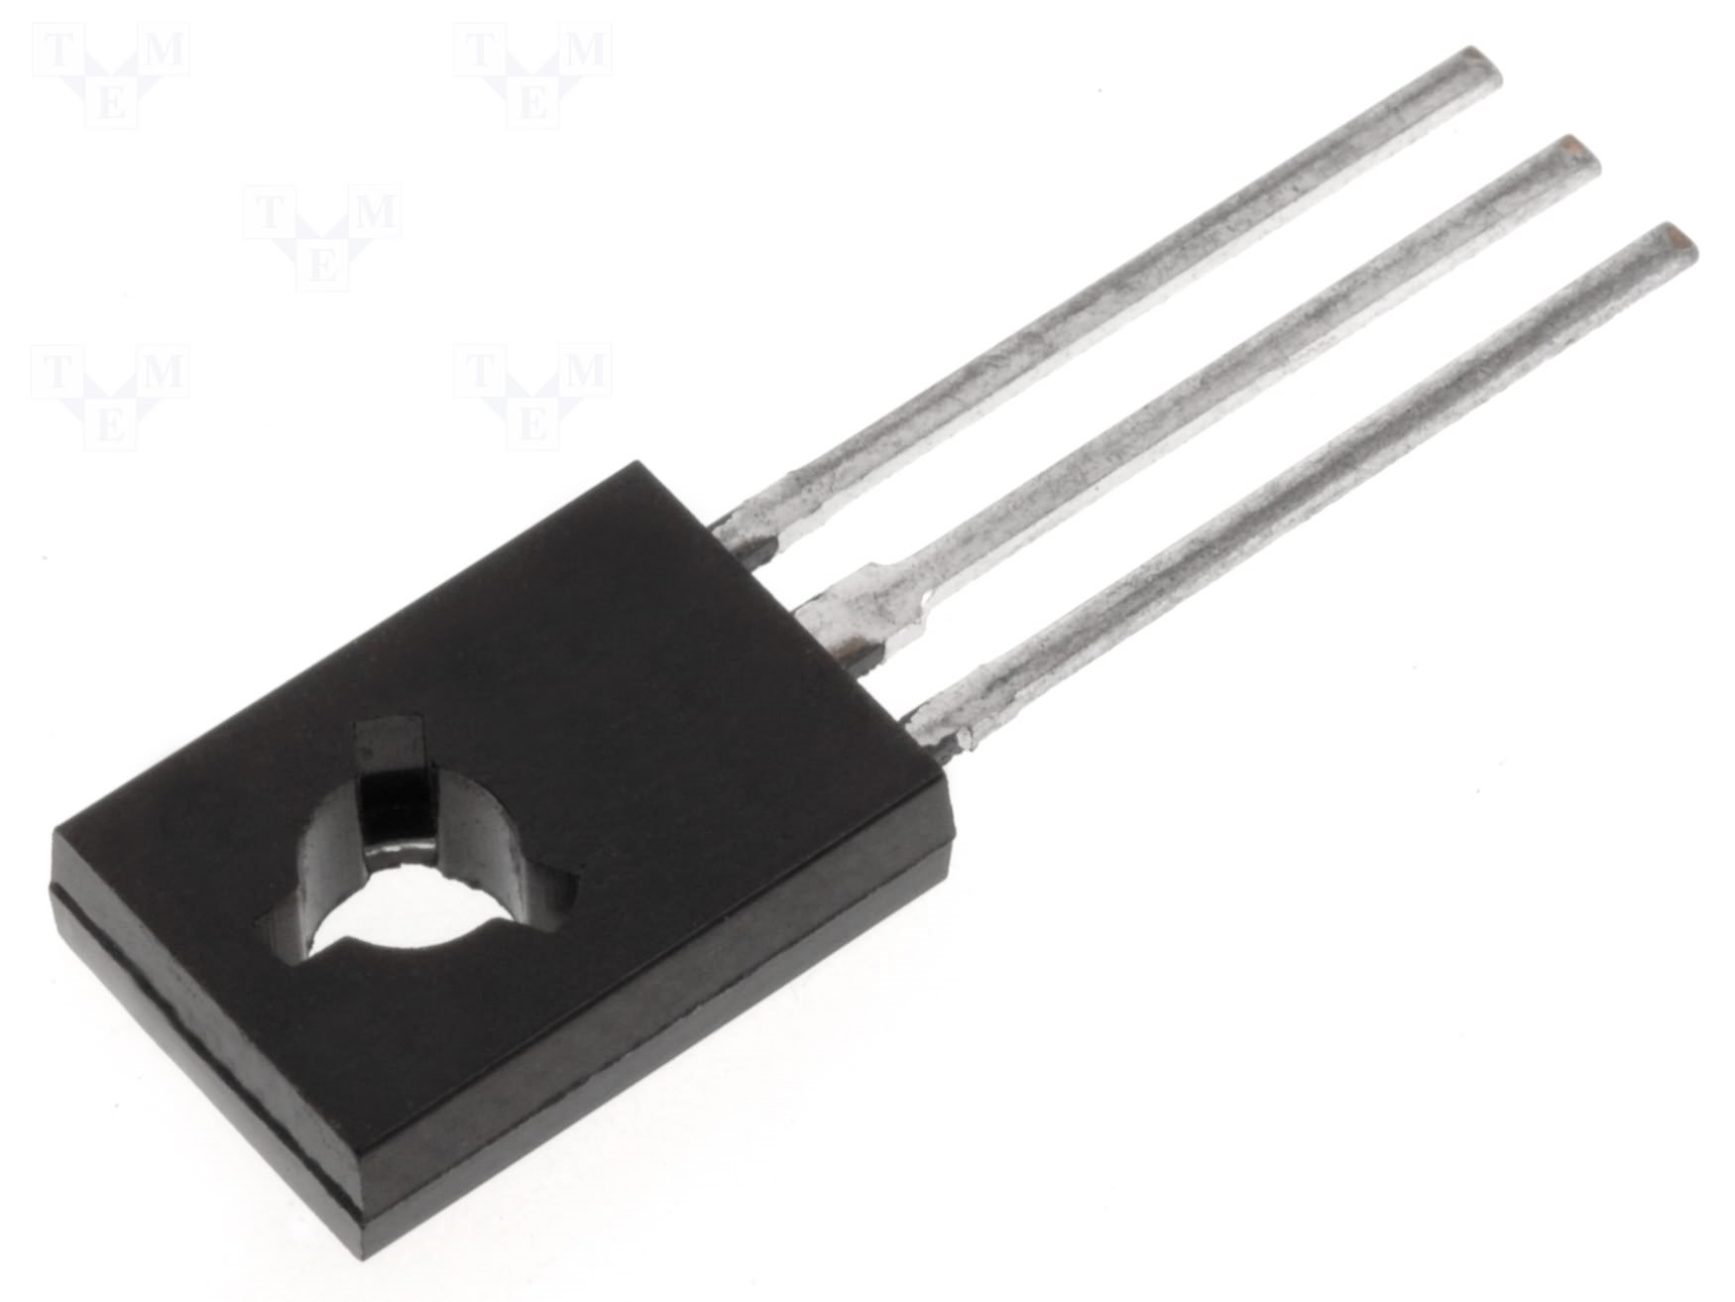

Fig.6: A transistor (BD135).

The transistor is the fundamental building block of modern electronic devices, and its presence is ubiquitous in modern electronic systems.

### Advantages:

The key advantages that have allowed transistors to replace their vacuum tube predecessors in most applications are

* Small size and minimal weight, allowing the development of miniaturized electronic devices.
* Highly automated manufacturing processes, resulting in low per-unit cost.
* Lower possible operating voltages, making transistors suitable for small, battery-powered applications.
* No warm-up period for cathode heaters required after power application.
* Lower power dissipation and generally greater energy efficiency.
* Higher reliability and greater physical ruggedness.
* Extremely long life. Some transistorized devices have been in service for more than 30 years.
* Complementary devices available, facilitating the design of [complementary-symmetry](http://en.wikipedia.org/w/index.php?title=Complementary-symmetry&action=edit&redlink=1) circuits, something not possible with vacuum tubes.
* Insensitivity to mechanical shock and vibration, thus avoiding the problem of [microphonics](http://en.wikipedia.org/wiki/Microphonics) in audio applications.

1. **RESISTOR:**

A resistor is a two-terminal electronic component that produces a voltage across its terminals that is proportional to the electric current passing through it in accordance with Ohm's law.

V = IR

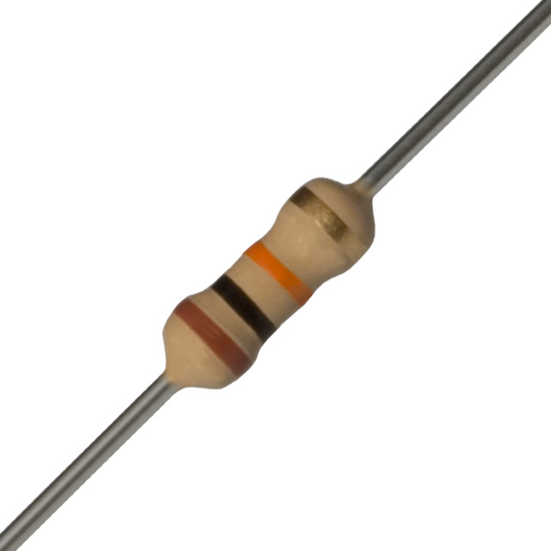

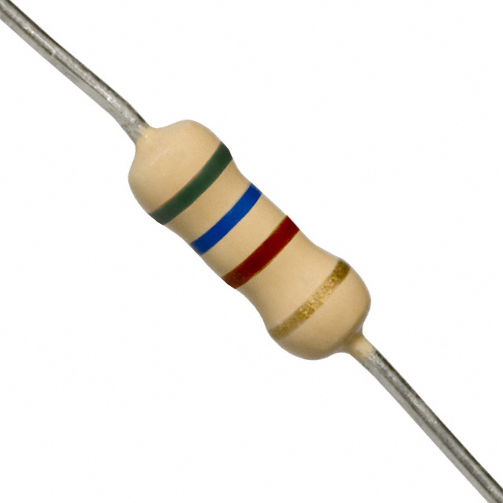

Fig.7: 10KΩ & 560Ω resistor.

Resistors are elements of electrical networks and electronic circuits and are ubiquitous in most electronic equipment. Practical resistors can be made of various compounds and films, as well as resistance wire. The primary characteristics of a resistor are the resistance, the tolerance, maximum working voltage and the power rating. Other characteristics include temperature coefficient, noise, and inductance. Less well-known is critical resistance, the value below which power dissipation limits the maximum permitted current flow, and above which the limit is applied voltage. Critical resistance depends upon the materials constituting the resistor as well as its physical dimensions; it's determined by design.

Resistors can be integrated into hybrid and printed circuits, as well as integrated circuits. Size, and position of leads are relevant to equipment designers; resistors must be physically large enough not to overheat when dissipating their power.

1. **CAPACITOR:**

A capacitor or condenser is a passive electronic component consisting of a pair of conductors separated by a dielectric. When a potential difference exists across the conductors, an electric field is present in the dielectric. This field stores energy and produces a mechanical force between the conductors. The effect is greatest when there is a narrow separation between large areas of conductor; hence capacitor conductors are often called plates.

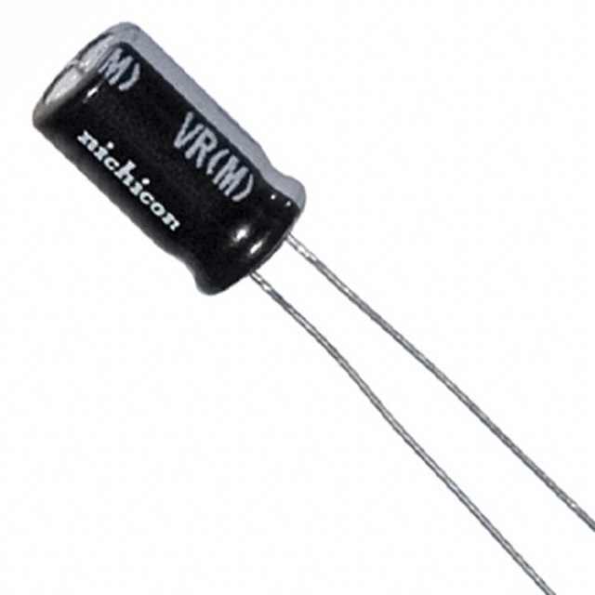

Fig.8: A typical electrolytic capacitor

An ideal capacitor is characterized by a single constant value, capacitance, which is measured in farads. This is the ratio of the electric charge on each conductor to the potential difference between them. In practice, the dielectric between the plates passes a small amount of leakage current. The conductors and leads introduce an equivalent series resistance and the dielectric has an electric field strength limit resulting in a breakdown voltage.

Capacitors are widely used in electronic circuits to block the flow of direct current while allowing alternating current to pass, to filter out interference, to smooth the output of power supplies, and for many other purposes. They are used in resonant circuits in radio frequency equipment to select particular frequencies from a signal with many frequencies.

1. **Infrared sensor:**

An infrared sensor is a device that can detect infrared light (which is below the optical spectrum) for use to a purpose. Most of the remote controls for TVs and other entertainment equipment use infrared energy as the transmission medium to carry information between the control and the equipment to be operated. Infrared sensors also have important scientific, military, security and rescue applications since they can "see" the "radiant heat energy" which is infrared radiation. This electromagnetic energy is in the wavelengths from about 750 nm, which is the lower end of the optical spectrum, to well over 10,000 nm, deep in the infrared.

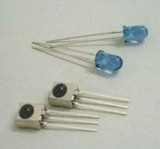

Fig.9: Infrared LEDs & Sensors.

The main part of the system is a photo detector or photo sensor. And it works based on black body radiation, which it the emission of energy based on the temperature of the object. As the radiant energy is a direct function of temperature, even the slightest difference in temperature results in the radiation of a slightly different wavelength of infrared light. A little hotter, a higher frequency or shorter wavelength, more toward visible light. A little cooler, and the opposite effect follows. The infrared radiation falls on the sensor and, through photoelectric effect, changes the "nature" of the chemistry/physics of the photosensitive material. This is seen by supporting electronics as a change of resistance which changes current or voltage in the circuitry according to the way it was designed.

1. **Voltage Regulator IC (7805):**

The **78xx** (also sometimes known as **LM78xx**) series of devices is a family of self-contained fixed linear voltage regulator integrated circuits. The 78xx family is a very popular choice for many electronic circuits which require a regulated power supply, due to their ease of use and relative cheapness.

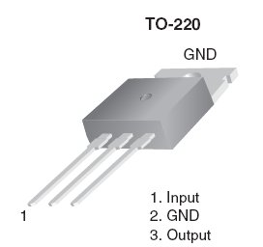

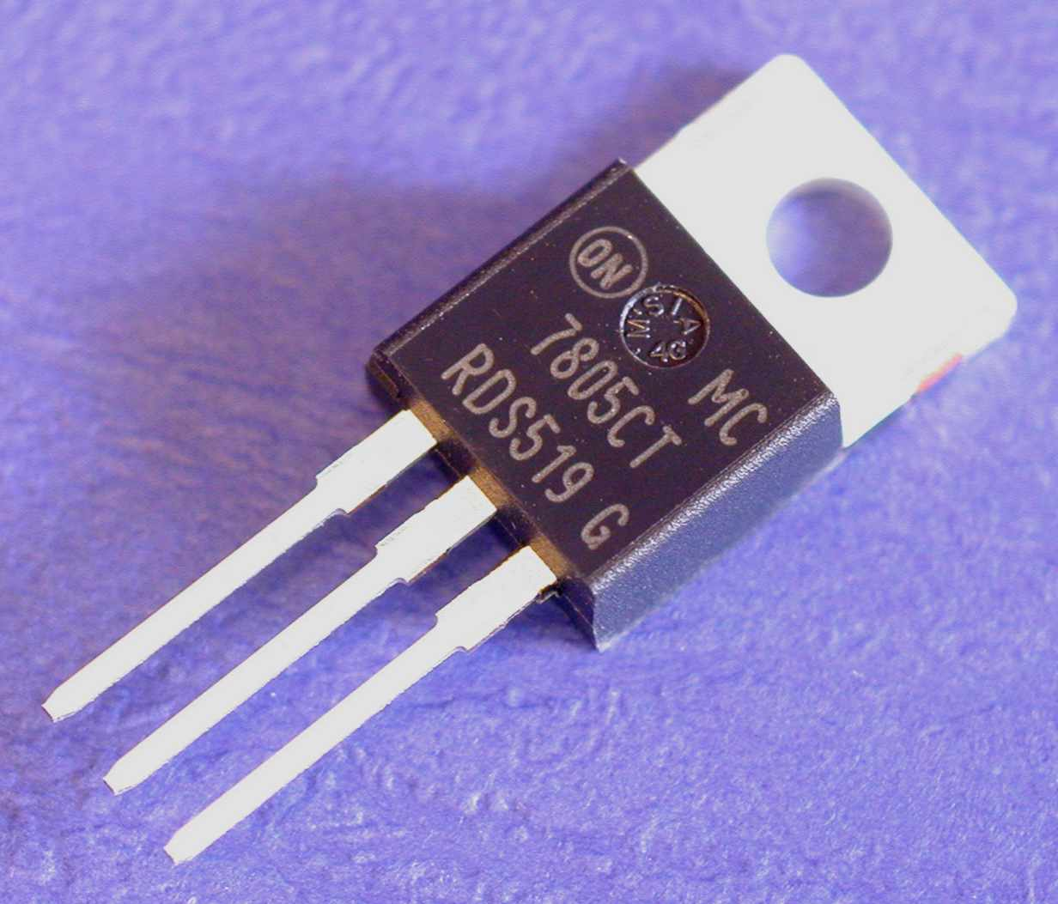

Fig.10: Physical view & pin diagram of 7805 IC.

When specifying individual ICs within this family, the *xx* is replaced with a two-digit number, which indicates the output voltage the particular device is designed to provide (for example, the 7805 has a 5 volt output, while the 7812 produces 12 volts). The 78xx lines are positive voltage regulators, meaning that they are designed to produce a voltage that is positive relative to a common ground. These devices typically support an input voltage which can be anywhere from a couple of volts over the intended output voltage, up to a maximum of 35 or 40 volts, and can typically provide up to around 1 or 1.5 amps of current (though smaller or larger packages may have a lower or higher current rating).

1. **Infrared remote switch:**

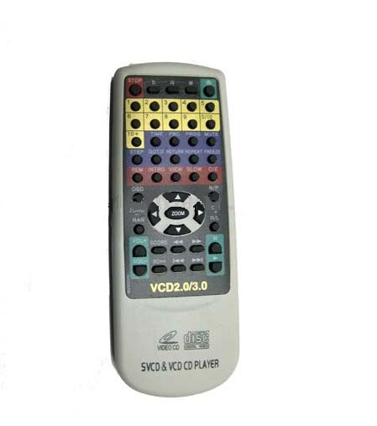

Fig.11: a Infrared remote switch

A remote control is a component of an electronics device, most commonly a television set, used for operating the device wirelessly from a short line-of-sight distance.

The remote control can be contracted to remote or controller. Commonly, remote controls are Consumer IR devices used to issue commands from a distance to televisions or other consumer electronics such as stereo systems, DVD players and dimmers. Remote controls for these devices are usually small wireless handheld objects with an array of buttons for adjusting various settings such as television channel, track number, and volume. In fact, for the majority of modern devices with this kind of control, the remote contains all the function controls while the controlled device itself only has a handful of essential primary controls. Most of these remotes communicate to their respective devices via infrared (IR) signals. Television IR signals can be mimicked by a universal remote, which is able to emulate the functionality of most major brand television remote controls. They are usually powered by small AAA size batteries.

1. **Circuit Diagram:**



Fig.12: Circuit diagram of the remote controlled car.

1. **Working procedure:**
2. **Infrared remote control system:**

Use of IR (infrared) light as a method for wireless communication has become popular for remote control applications. There are a number of different standards for such communication. In this project the widely used RC5 coding scheme from Philips is used.



Fig.13: RC5 frame format.

The RC5 code is a 14-bit word bi-phase coded signal (see Figure 2). The two first bits are start bits, always having the value “1”. The next bit is a control bit, which is toggled every time a button is pressed on the remote control transmitter. This gives an easy way of determining whether a button is pressed and held down, or pressed and released continuously. Five system bits hold the system address so that only the right system responds to the code. Usually, TV sets have the system address 0, VCRs the address 5 and so on. The command sequence is six bits long, allowing up to 64 different commands per address. The bits are transmitted in bi-phase code. An example where the command 0x35 is sent to system 5 is shown.



Fig.14: Example of Transmission



Fig.15: Bi-phase Coding.

1. **Microcontroller programming:**

For microcontroller programming we use the language “BASCOM”. In programming we use the interrupt feature of microcontroller. When interrupt pin which is connected to the sensor output through an inverter circuit using transistor, the microcontroller started to store the data received from the sensor in a register. Then the microcontroller matches the register data with some predefined data saved in the program. When found matches the microcontroller makes its certain output pin high logic level. The pin no. of the microcontroller which becomes high due to pressing the buttons in remote controller is given below.

|  |  |  |
| --- | --- | --- |
| Button pressed | Pin no. | Action |
| Program+ | 3 | Forward |
| Program- | 2 | Backward |
| Vol up+ | 22 | Right turn |
| Vol up- | 23 | Left turn |

1. **Motor handling:**

The maximum DC sourcing current of the ATmega32L is 40mA, Which is insufficient for the motors to run. The minimum current required to run two motors is approximately 250mA which can be easily determined by trial & error method. To solve this problem, we use relays as switch between the motors and batteries. The relay driver circuit is made with transistor. When the pin connected to the base of transistor becomes high, the transistor is switched to ON and the coil of relay is charged. So, the relay is switched ON. The general purpose relay can handle up to 10A DC current. Hence the motor can easily run which in turn make the car moving.

1. **Flowchart:**



1. **Program for microcontroller:**

$regfile = "m8def.dat"

$crystal = 1000000

Config Portd = Input

Config Portb = Output

Config Portc = Output

Dim A(4) As Byte , I As Byte , J As Byte , B As Byte , M As Byte

Dim D As Integer , F As Integer

'****************************************************************************************

Config Timer1 = Counter , Prescale = 256

Enable Int0

Config Int0 = Rising

Enable Interrupts

On Int0 Remote

Do

Loop

End

Remote:

Start Timer1

Do

Loop Until Pind.2 = 1

F = Timer1

Do

Loop Until Pind.2 = 0

Do

Loop Until Pind.2 = 1

Do

Loop Until Pind.2 = 0

For I = 1 To 4

For J = 7 To 0 Step -1

Timer1 = 0

Do

Loop Until Pind.2 = 1

B = Timer1 \ 4

A(i).j = B

Do

Loop Until Pind.2 = 0

Next

Next

Select Case A(3)

Case 40:

Portb = 0

Portc = 0

Case 8:

Portb = 0

Waitms 50

Portb = 4

Case 2:

Portc = 1

Waitms 500

Portc = 0

Case 226:

Portc = 2

Waitms 500

Portc = 0

Case 96:

Portb = 0

Waitms 50

Portb = 4

Case 34:

Portb = 0

Waitms 50

Portb = 2

End Select

Waitms 100

Return

1. **PCB Layout:**

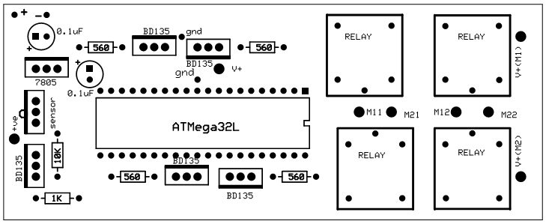

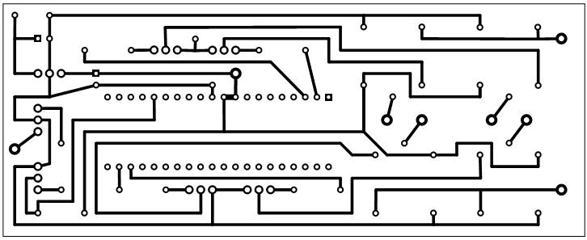

5 inch

2 inch

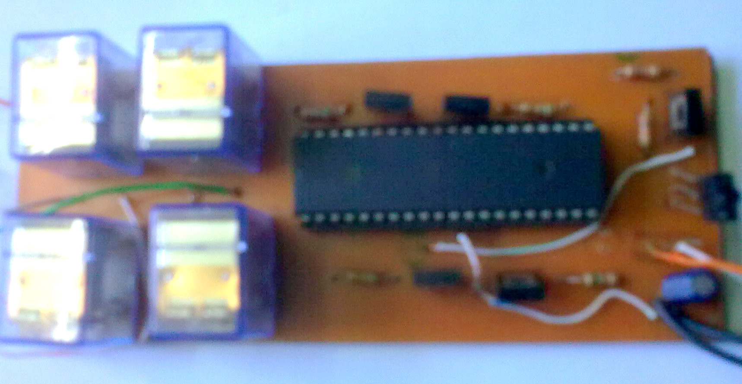

Fig.16: top view, copper layer & PCB board after soldering.

1. **The car after assembling the control system:**

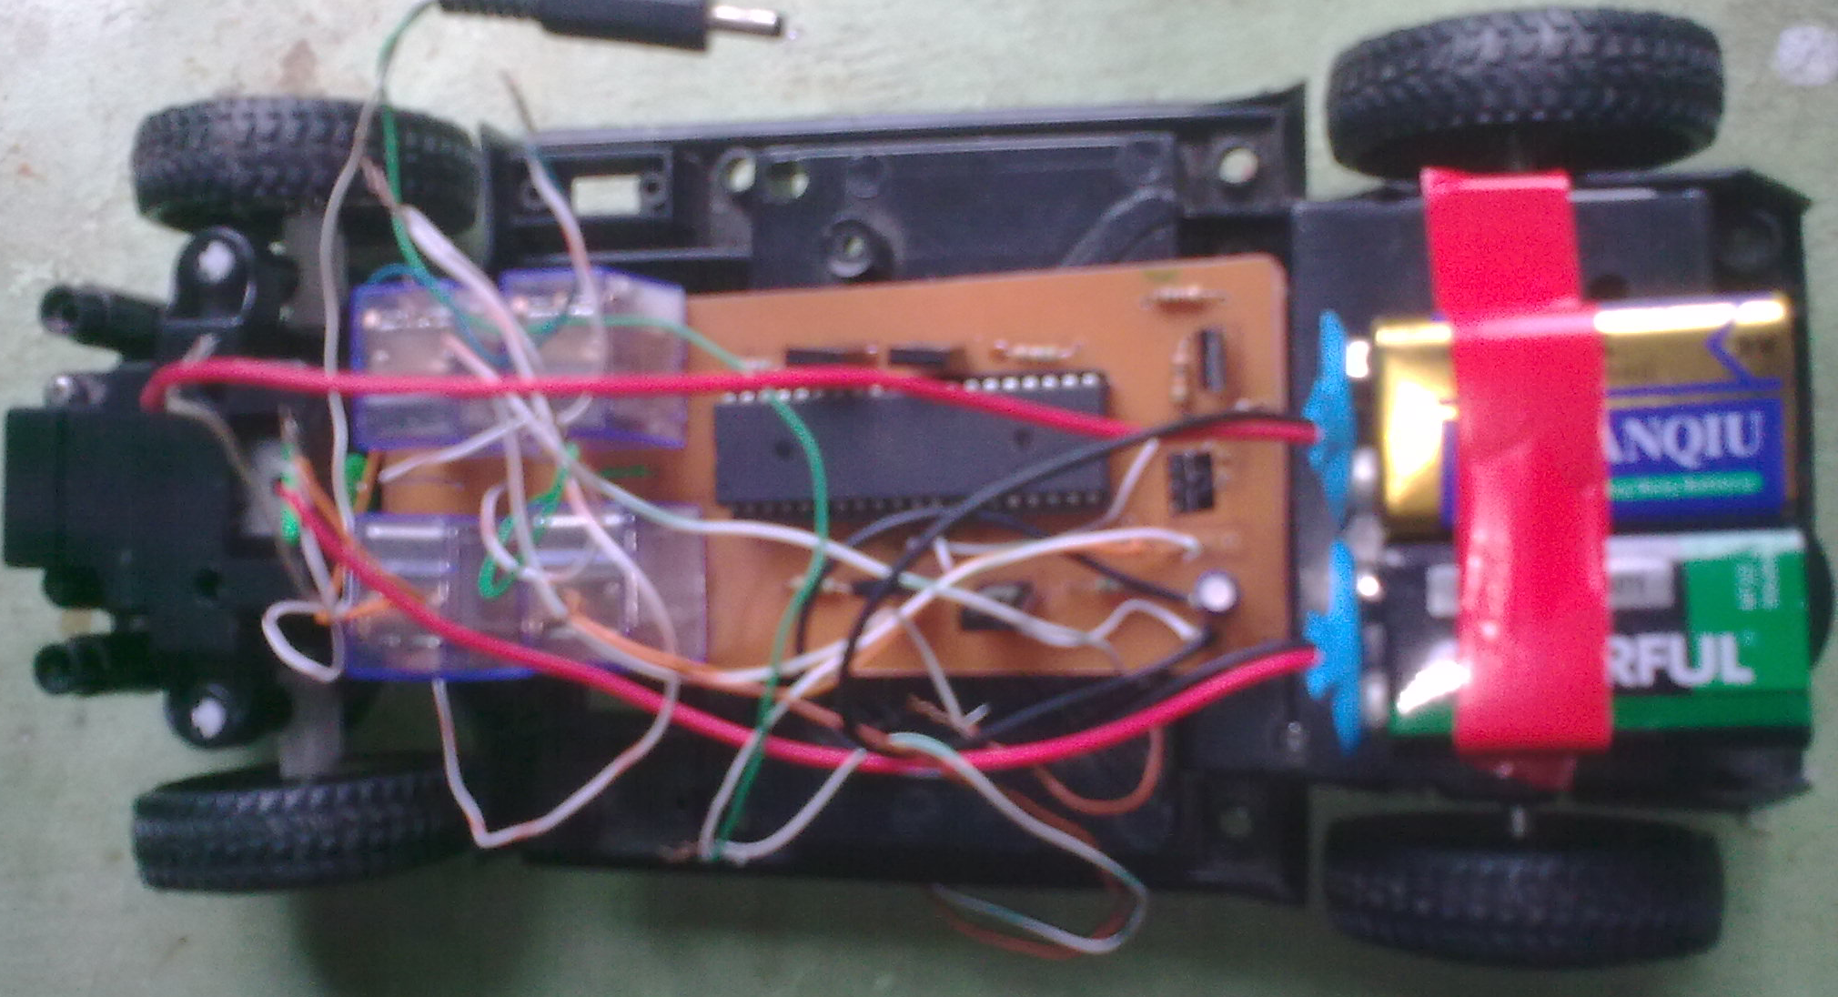

1. **Discussion & recommendation:**
2. **Discussion:**
3. It is very important to made the right connection of microcontroller. If we inter change the connection +Vcc and GND terminal, the microcontroller may be damaged.
4. The maximum DC sourcing current of the ATmega32L is 40mA, we can not exceed this limit.
5. The initial torque of the motor we used is low. So we can’t make the car heavy.
6. **Recommendation:**
7. We use +9V (Non-Rechargeable) battery in this project. Anyone can use the 6V, 4.5Ah (Rechargeable) battery.
8. We use the infrared signal to give our command to microcontroller while the RF signals can be used which is more convenient.
9. **Practical life application of the remote control car**
10. This car can be controlled from long distance. So it can be used in traffic control, police investigations etc.
11. This car can be used in those places where man cannot go.
12. This type of car a great aspect over the toy business.